Introduction

ERPNext is an end-to-end business solution that helps you to manage all your business information in one application and use it to not only manage operations but also enables you to take informed decisions well in time to remain ahead of your competition. It forms a backbone of your business to add strength, transparency and control to your enterprise.

Among other things, ERPNext will help you to:

* Track all Invoices and Payments.
* Know what quantity of which product is available in stock.
* Identify and track your key performance indicators (KPI's).
* Identify open customer queries.
* Manage payroll.
* Assign tasks and follow up on them.
* Maintain a database of all your customers, suppliers and their contacts.
* Prepare quotes.
* Tracking your budgets and spending
* Determine effective selling price based on the actual raw material, machinery and effort cost.
* Get reminders on maintenance schedules.
* Publish your website.

Installation

We are explaining how to install ERPNext in Ubuntu 16.04 LTS step by step.

Be root! To install ERPNext make sure you have sudo access or in system, you logged in as a root. if not then run below command.

sudo su

Create a user.

adduser frappe

Give that user sudo priviledge.

usermod –aG sudo frappe

Login into user – frappe.

Ubuntu server 16.04 does not come with python preinstalled, python 2.7 is required to run ERPNext. below command will install python 2.7 in ubuntu server.

sudo apt-get install python-minimal

We will get the install.py file from the github using below command to install ERPNext.

wget https://raw.githubusercontent.com/frappe/bench/master/playbooks/install.py

Run the the script depending on development or production enviroment, while the script is running you will be asked for Passwords for Frappe Administrator and MariaDB (root) will be asked.

python install.py –develop

The installation will prompt to give username and password, and also administrator password.

Frappe is now installed. Now go to frappe location.

cd FRAPPE_HOME

Create a new bench. The init command will create a bench directory with frappe framework installed. It will be setup for periodic backups and auto updates once a day.

bench init frappe-bench && cd frappe-bench

Add a site. Frappe apps are run by frappe sites and you will have to create at least one site. The new-site command allows you to do that.

bench new-site site1.local

Add apps. The get-app command gets remote frappe apps from a remote git repository and installs them. Example: erpnext

bench get-app erpnext https://github.com/frappe/erpnext

Install erpnext. To install an app on your new site, use the bench install-app command.

bench --site site1.local install-app erpnext

To start using the bench, use the bench start command

bench start

Now, open the host website browser and browse

<https://localhost:8000>

To set up erpnext

username : Administrator

password: xxxxxx

Modules

There are many modules in ERPNext. We have set up five modules. They are

* POS
* Invoice
* Purchase
* Sales
* Accounts

**POS:** In the retails business, invoicing needs to done very quickly, hence should less dependency. In the ERPNext, you can create POS Invoices, even when not connected to the internet. POS Invoices created in the offline mode will be saved locally in the browser. Whenever it gets connection it will transfer data.

### Customer

In POS, user can select the existing customer during making an order or create the new customer. This features works in the offline mode also.

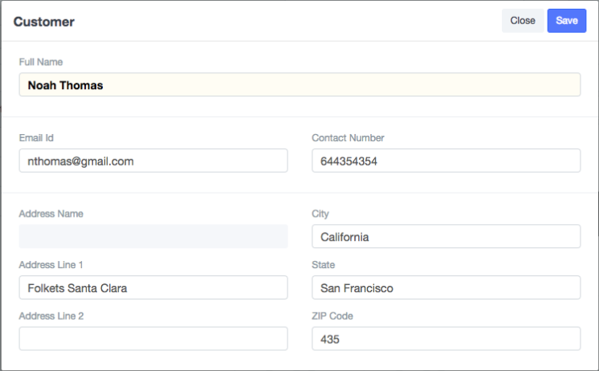

### Adding an Item

At the billing counter, the retailer needs to select Items which the consumer buys. In the POS interface you can select an Item by two methods. One, is by clicking on the Item image and the other, is through the Barcode / Serial No.

### Make Payment

After all the Items and their quantities are added into the cart, you are ready to make the Payment. Payment process is divided into 3 steps -

1. Click on “Make Payment” to get the Payment window.
2. Select your “Mode of Payment”.
3. Click on “Pay” button to Save the document.

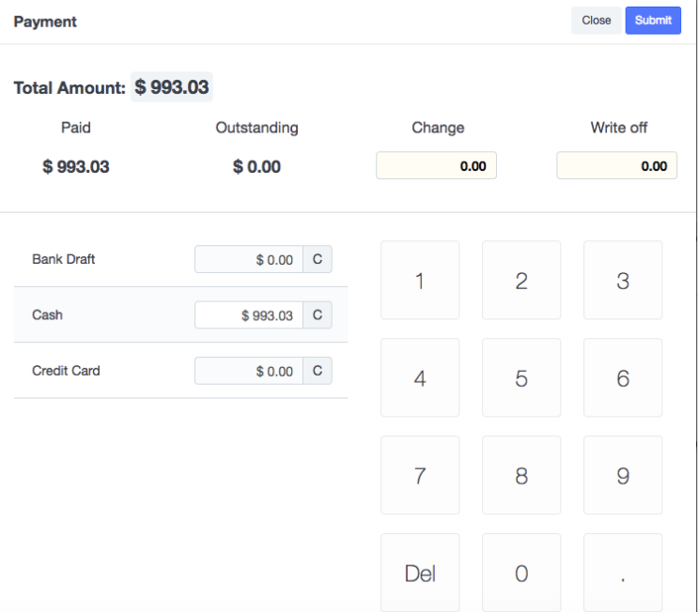

**Invoice:** There are 3 types of invoice in ERPNext system. They are

* Sales invoice
* POS invoice
* Purchase invoice

# Sales Invoice

A Sales Invoice is a bill that you send to your customers, against which the customer processes the payment. Sales Invoice is an accounting transaction. On submission of Sales Invoice, the system updates the receivable and books income against a Customer Account.

To create a sales invoice

Accounts > Billing > Sales Invoice > New Sales Invoice

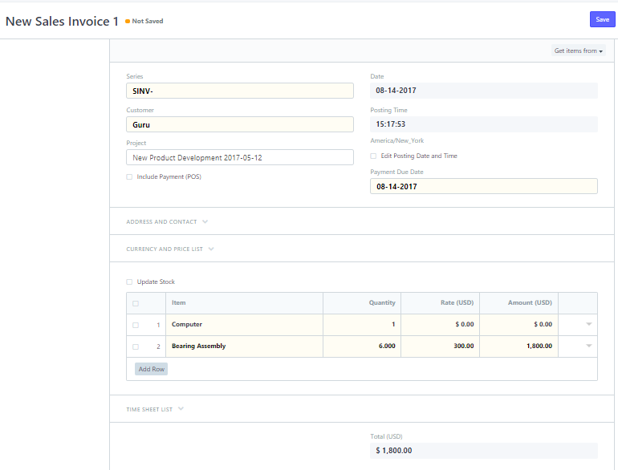

Point of Sales Invoice

Point of sales invoice is already covered in POS section.

Purchase invoice

Purchase Invoice is the exact opposite of your Sales Invoice. It is the bill that your Supplier sends you for products or services delivered. Here you accrue expenses to your Supplier. Making a Purchase Invoice is very similar to making a Purchase Order.

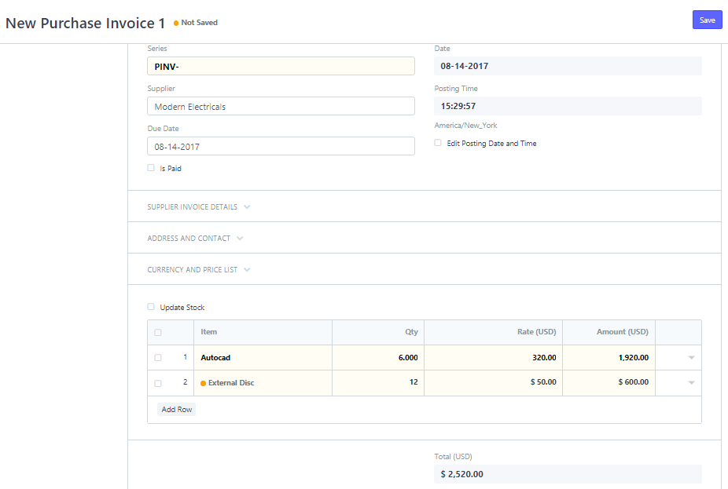

**Purchase:** If a business involves physical goods then buying is one of the core business activity . Buying in right amount and in right quantities can affect cash flow and profitability. ERPNext contains a set of transactions that will make your buying process as efficient and seamless as possible.

1. **Suppliers:** First of all suppliers are those who provides you product or services. Suppliers could be company or individuals.

Screenshot to create a supplier:

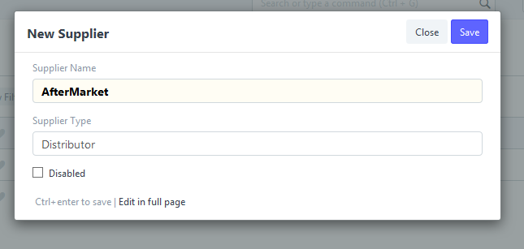

Once supplier is saved, we will find option to create contact and address for suppliers. Contacts and Addresses in ERPNext are stored separately so that we can create multiple contact and address for multiple suppliers.

Screenshot to add Contact and Address of supplier:

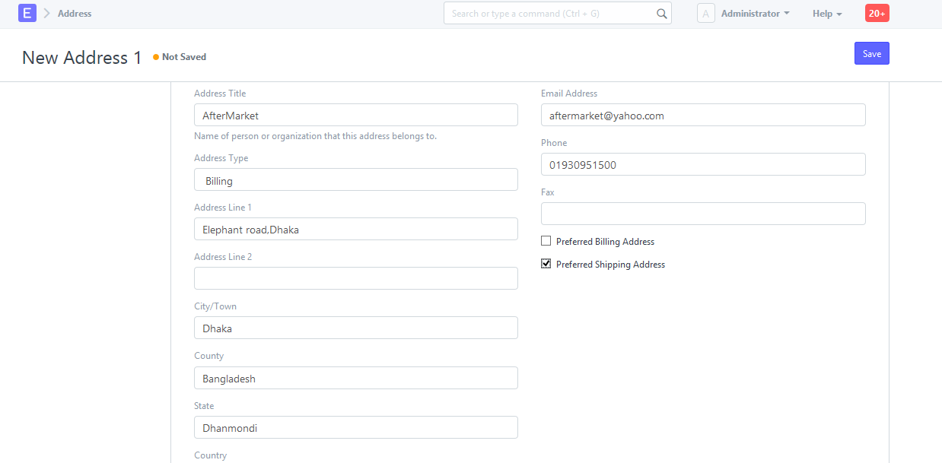

1. **Request For Quotation:**

Request for Quotation is a document that an organization submits to one or more suppliers eliciting quotation for items. There are two ways to generate supplier quotation from request for quotation.

1. For User
2. For Supplier

Screenshot to create Request for Quotation for a new item:

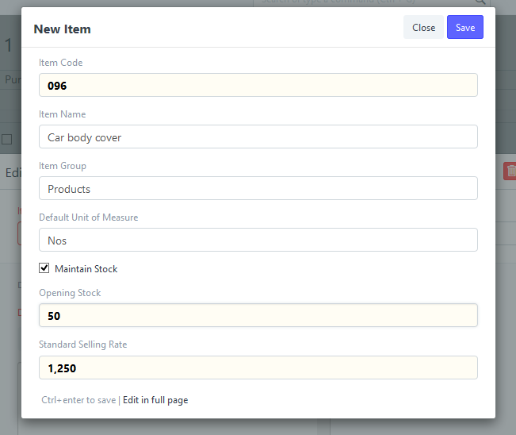

1. **Supplier Quotation:**

Supplier Quotation is a formal statement of promise by potential suppliers to supply the goods or services required by a buyer, at specific prices and within a specified period.

Quotation may contain

1. Sale
2. Payment
3. Warranties

Suppliers Quotations are not necessary for most small businesses. If we have multiple Suppliers who supply us with same items, we can send out request for quote to various suppliers.

If we have centralized buying, we may want to record all the quotes so that

1. We can easily compare prices in future
2. Audit whether all suppliers were given the opportunity to quote.

Screenshot to create a supplier contact:

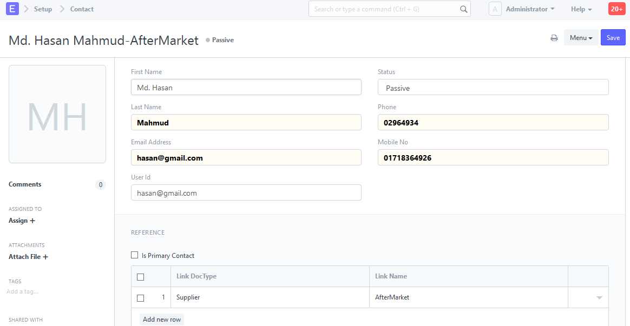

Screenshot to create a Supplier Quotation:

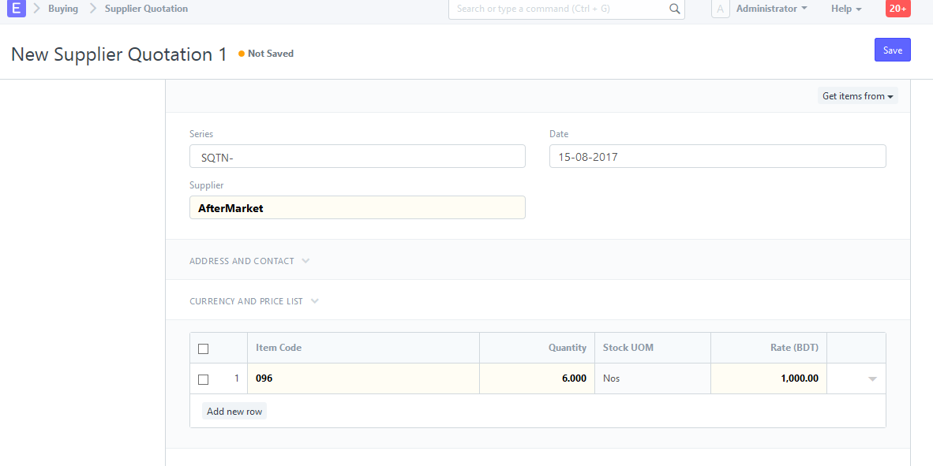

1. **Purchase Order :**

A Purchase Order is analogous to a Sales Order. It is usually a binding contract our supplier that we promise to but a set if items under the given conditions.

Screenshot to create a Purchase Order:

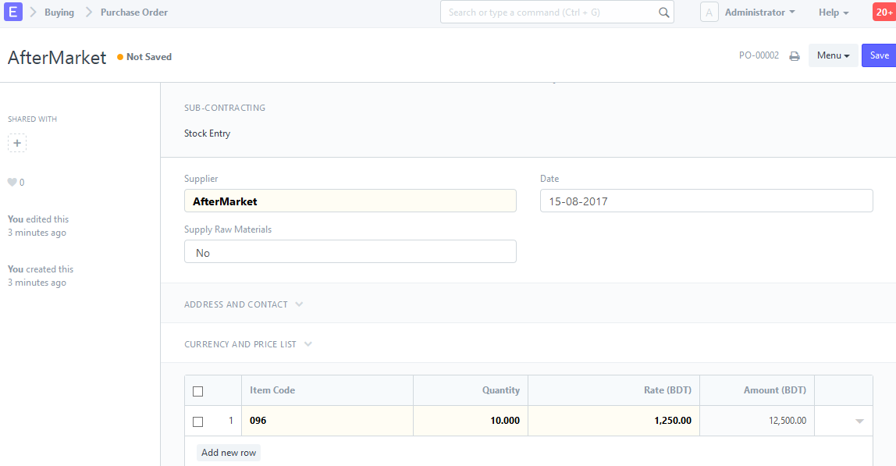

Screenshot to create a Request for Quotation:

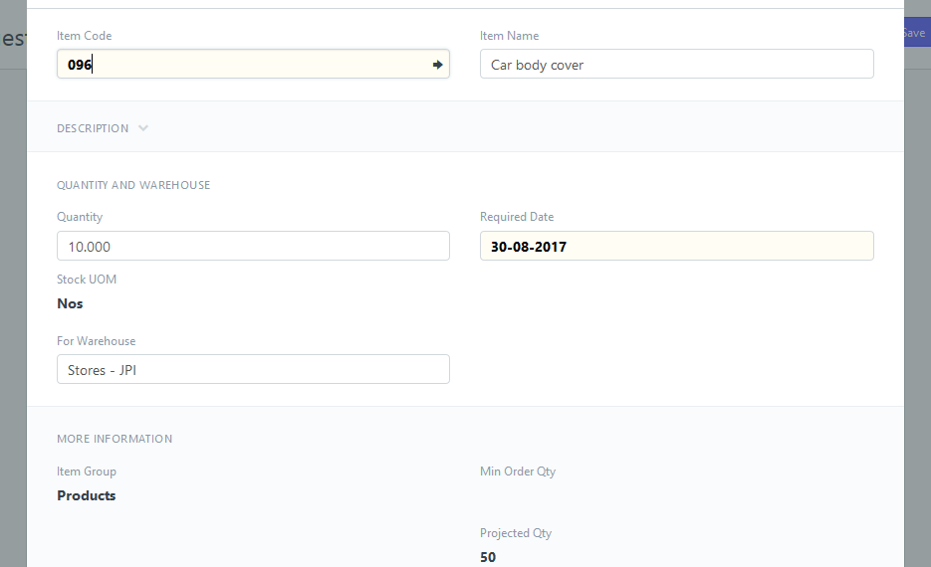

* **Setup:**

It is two types.

1. Buying Settings
2. Suppliers type

**Buying Settings:** Buying Settings is where we can define properties which will be applied in the buying modules transaction.

**Supplier type:** A supplier may be distinguished from a contractor or subcontractor, who commonly adds specialized input to deliverables.

1. **Purchase Taxes:**

For tax account that we want to use in the tax templates, you must mention then as type “Tax” in your Chart of Accounts.

Tax will be booked under account leader.

Screenshot of tax and charge template:

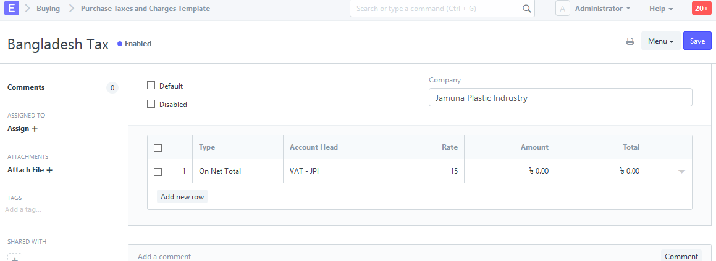

1. **Supplier Scorecard:**

Supplier Scorecard is an evaluation tool used to assess the performance of suppliers. Suppliers Scorecards can be used to keep track of items quality, delivery and responsiveness of suppliers across long periods of time. The data is used to help in purchasing decision.

Suppliers Scorecard is manually created for each suppliers.

Sales: Selling is the communication that happens with the customer prior to and during the sale. Two topic related to sales is described below.

* Quotation
* Sales order

**Quotation**

During a sale, the customer may request for a written note about the products or services you are planning to offer, along with the prices and other terms of engagement. This is called a “Proposal” or an “Estimate” or a “Pro Forma Invoice” or a **Quotation**.

A Quotation contains details about:

* The recipient of the Quotation
* The Items and quantities you are offering.
* The rates at which they are offered.
* The taxes applicable.
* Other charges (like shipping, insurance) if applicable.
* The validity of contract.
* The time of delivery.
* Other conditions

To create a new Quotation navigate to: Selling > Quotation > New Quotation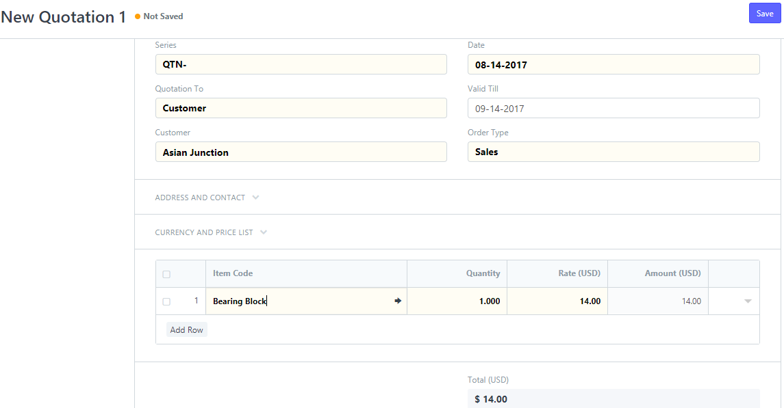

**Sales Order**

The Sales Order confirms your sales and triggers purchase (Material Request) shipment (Delivery Note), billing (Sales Invoice) and manufacturing (Production Plan) A Sales Order is usually a binding Contract with your Customer.

Sales order Flow Chart

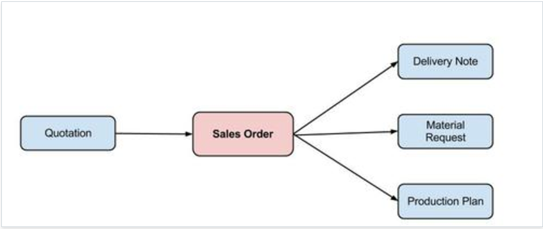

To create a new Sales Order go to: Selling > Sales Order > New Sales Order

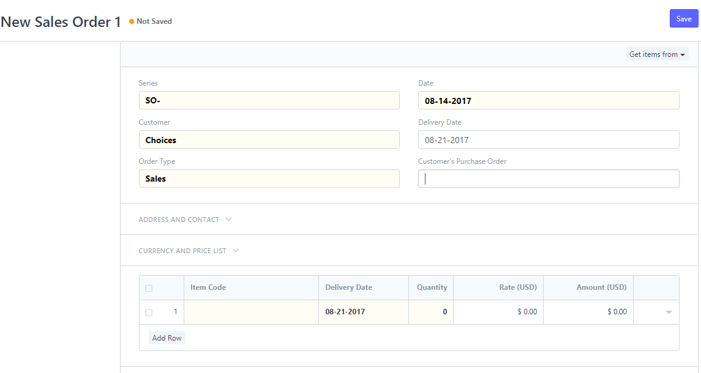

To set up sales module perfectly there are some prerequisites.

* Item entry
* Shipping rule
* Sales partner
* Create customer

**Accounts:**

At the end of sales and purchase cycle comes billing and payments. You may have an accountant in your team, or you may be doing accounting yourself, or you may have outsourced your accounting. In all the cases financial accounting forms the core of any business management system like an ERP.

In ERPNext, your accounting operations consist of 3 main transactions:

* Sales Invoice: The bills that you raise to your Customers for the products or services you provide.
* Purchase Invoice: Bills that your Suppliers give you for their products or services.
* Journal Entries: For accounting entries, like payments, credit and other types.

Accounts module has many functionalities. They are

1. Chart Of Accounts
2. Updating Opening Balance in Accounts
3. Sales Invoice
4. Point of Sale Invoice
5. Purchase Invoice
6. Payments
7. Journal Entry
8. Payment Entry
9. Multicurrency Accounting
10. Advance Payment Entry
11. Payment Request
12. Credit Limit
13. Bank Guarantee
14. Accounting Reports
15. Accounting Entries
16. Managing Fixed Assets
17. Budgeting
18. Item Wise Taxation
19. Recurring Orders and Invoices
20. Pricing Rule

To set up the accounts module perfectly you need to do set up the following things first,

1. Fiscal Year
2. [Cost Center](https://erpnext.org/docs/user/manual/en/accounts/setup/cost-center)
3. Accounts Settings
4. Tax Rule

Field Customization :

To customize field, one need to go to the desired doctype to customize. There are two types of customization :

1. Default customization for a particular doctype.
2. Customization for a particular element in doctype list.

**Steps:**

* 1. For default customization that will take effect to all the list items one need to go to the particular doctype. On the doctype first page where a list of doctype element is shown go to the upper right corner of that page. Select menu and select customize.
  2. To customize a specific element of doctype, select the element and go to that element page. Then go to the upper right corner and select menu and select customize.
  3. From there are various customization option.
  4. You can select and edit various options for a field from there.
  5. You can also select the dropdown arrow of an element and do more detailed customization.
  6. Also to customize field and change core elements you need to make sure that the custom icon is selected of that customization page on the upper right corner.

**Adding Custom Module:**

Adding custom takes more in-depth knowledge. First you need to decide what your custom module will do and what functions are needed for that particular module. Also you need to determine the workflow that will play in your module.

Steps:

1. Add a new doctype. Go to developer >> doctype list >> new doctype

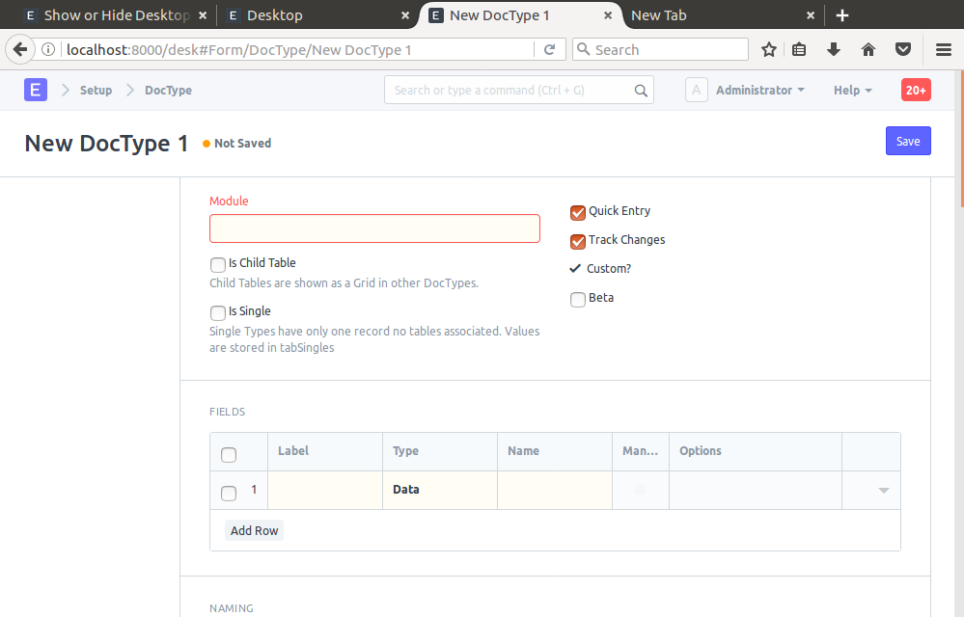

1. Add main doctype.

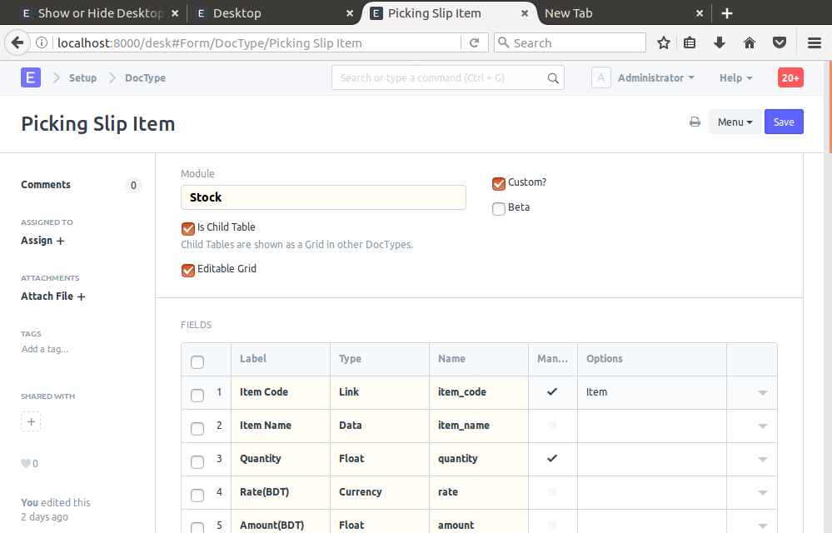

1. Add row and field
2. Naming Series

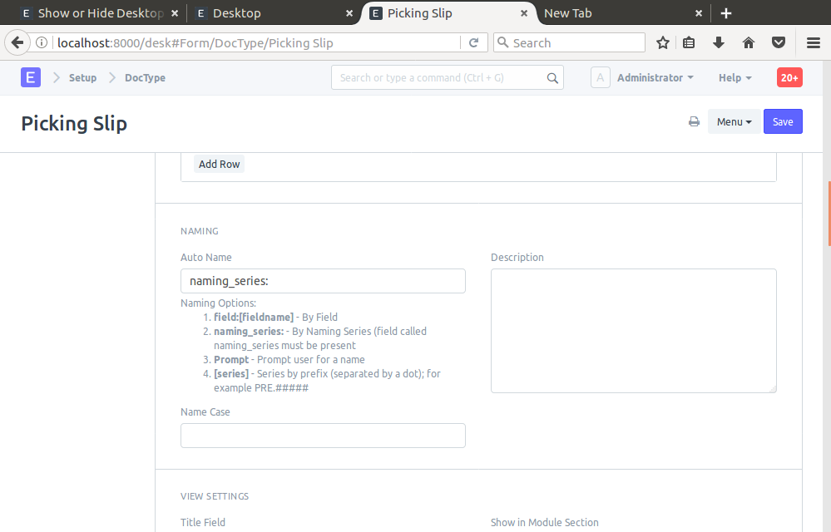

1. Naming the doctype.
2. Save.
3. To add child doctype.
4. Go to the doctype.
5. Select menu >> new doctype
6. Edit field
7. To add custom script go to custom script list >> new script
8. Add the doctype page name you want to add custom script for.
9. Save .

